RIHAM AHAMED ABDUL RAHEEM

HND COMPUTING IDM

TRINITY SCHOOL DATABASE MANAGEMENT SYSTEM

Contents

**INTRODUCTION** 2

**STRUCTURED QUERY LANGUAGE (SQL)** 2

**SQL SERVER MANAGEMENT STUDIO** 3

**PROCESS OF THE CREATION OF TRINITY MUSIC SCHOOL DATABASE SYSTEM.** 5

Create database & Accessing database 5

Create table, insert data and Interface design 6

**Student** 6

**Teacher** 8

**Class** 10

**Supplier** 12

**Instrument** 14

**QUERY DEMONSTRATION** 16

Task1: Student details with No of student registration for given month 16

Task2: Total Income received for a given month form the student 17

Task3: Student details with their playing instruments 18

Task4: Filter the student’s records based on the registration date 18

Task5: Show only the Part time classes 19

References 20

**List of Figure**

Figure 1: Microsoft SQL server management studio 4

Figure 2: Create TMS Database 5

Figure 3: Student table create query 6

Figure 4: Student table insert query 6

Figure 5: Student form design and code 7

Figure 6: Teacher table create query 8

Figure 7: Teacher table insert data query 8

Figure 8: Teacher form design and code 9

Figure 9: Class table create query 10

Figure 10: Class table insert data query 10

Figure 11: Class interface design and code 11

Figure 12: Supplier table create query 12

Figure 13: Supplier table insert data query 12

Figure 14: Supplier interface design and code 13

Figure 15: Instrument table insert data query 14

Figure 16: Instrument table create query 14

Figure 17: Instrument interface design and code 15

Figure 18: Task 1 Query 16

Figure 19: Task 2 Query 17

Figure 20: Task 3 Query 18

Figure 21: Task 4 Query 18

Figure 22: Task 5 Query 19

# **INTRODUCTION**

The Colombo-based Trinity Music School is currently erratic and outdated, requiring XYZ software solutions to create a corresponding database system for the school to transform their entire school with data processing methods to meet the school's demands for development and flexibility. Based registration management system.

This report will attempt to display and explain certain SQL queries, provide evidence user interfaces, outputs and data validations.

# **STRUCTURED QUERY LANGUAGE (SQL)**

The pronounced sequence "es-kue-el", is the language in which machines interact with databases. According to the American National Standards Instiute (ANSL) , SQL is the standard for interaction with relevant database management systems. One of the most basic and powerful features of SQL is that it allows developers to create, read, update, and delete (CRUD) operations on a database.

When it comes to database management systems, there are 4 main languages ​​that allow queries stored in a database and proper expression of configuration data.

They are:

1. Data Definition Language: Defines the structure of data and ensures that data is stored in ways that identify patterns. DDL reports implement the definition of metadata of a database. Creating plans, tables, codes, and controls within a database is all about DDL.
2. Data Manipulation language: Allows access and manipulation of data within a database. Whenever a machine needs to access something stored in a database, it can use the enabled DML.
3. Data Control Language: This language has a lot in common with DML, but the main difference is that DCL allows to control permissions to a database, ensures access queues and also provides the functionality of DML. Execution of DCL reports is highly transferable and includes rollback parameters.

The Structured query language implements all 4 languages ​​used in database management systems. It is therefore very important in the process of using databases for storage purposes. The following figure shows how each of these 4 languages ​​is imagined using commands in SQL. (tutorialspoint, 2021)

# **SQL SERVER MANAGEMENT STUDIO**

Microsoft SQL Server is a related database management system used to implement theTrinity Database System (TMS). SQL Server supports a wide range of transaction processing, business intelligence and analytics interfaces for the IT industry. It is one of the most widely used and marketed database technologies out there.

The standard language used to query databases As mentioned earlier, the SQL Server is built on top of one layer of SQL. SQL Server configured SQL processing is also known as Transact-SQL (T-SQL) and Microsoft-implemented implementation, which adds additional extensions to the standard configured query language.

SQL Server Management Studio was heavily used to create the Trinity database.

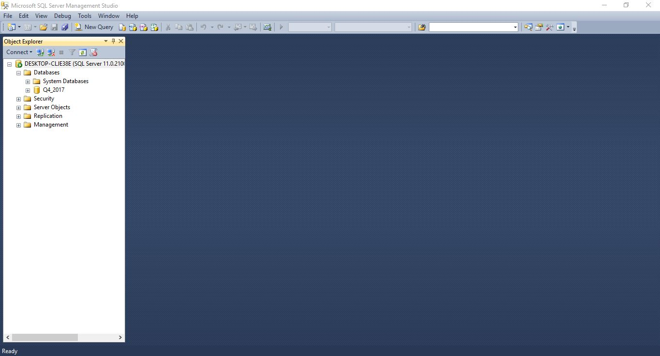The following is a picture of what the SQL Server Management Studio main interface looks like when connected to a server. (Erkec, 2020)

Figure : Microsoft SQL server management studio

It has a very user friendly and organized look and is very strong in dealing with even the biggest challenges faced in the development of related databases.

# **PROCESS OF THE CREATION OF TRINITY MUSIC SCHOOL DATABASE SYSTEM.**

The following attempt is the following steps from database creation to creating tables and then inserting data, along with justification and data verification.

## Create database & Accessing database

Figure : Create TMS Database

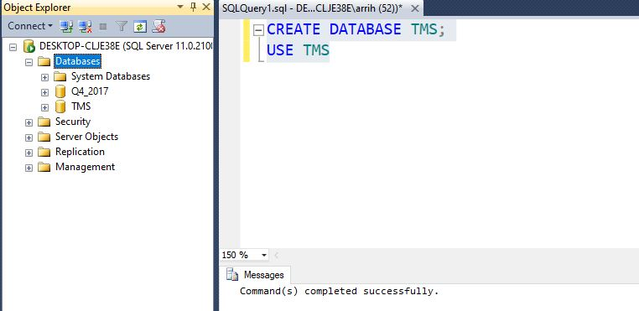

By executing these 2 queries, a database called "TMS" is created one after the other, prompting the database management system to use "TMS" as the current active database. So all the following queries will be done in the “TMS” database.

## Create table, insert data and Interface design

### **Student**

Figure : Student table create query

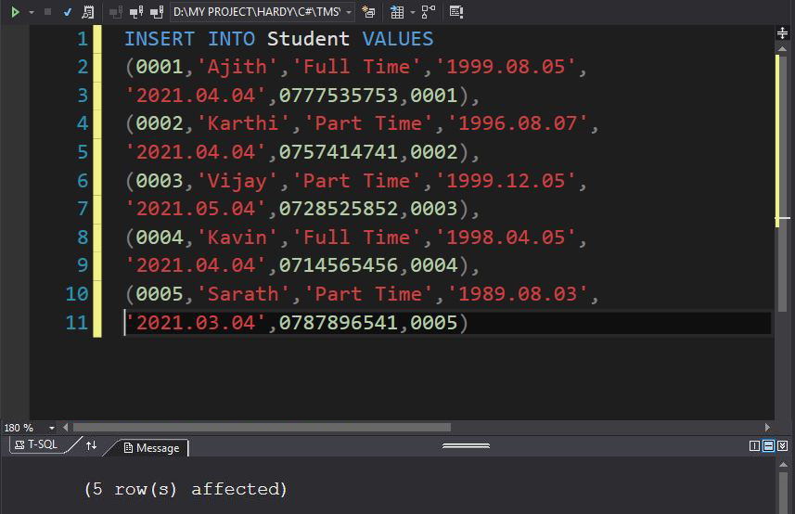

Figure : Student table insert query

Now a table called student is created, with 7 columns of data types of StudentID, Name, Type, DOB, Register_Date, Contact_Number and ClassID respectively, integer, varsar, varsar, date, date, integer and integer. The primary key is StudentID, so it is naturally unique and NULL. The foreign key is ClassID references class table. The insert query contains only the data types that are subject to the table's scheme, so the data is valid and the data entered.

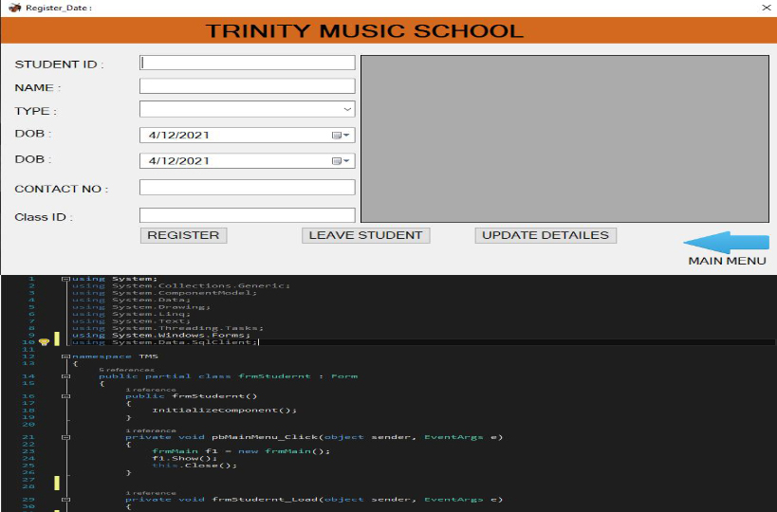

Figure : Student form design and code

### **Teacher**

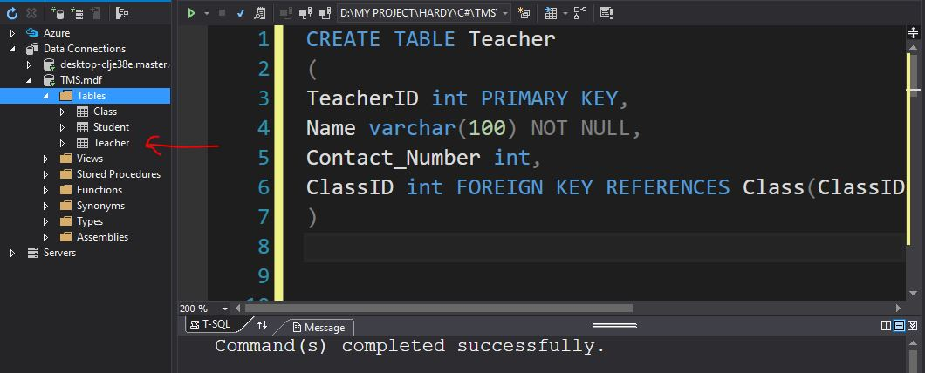

Figure : Teacher table create query

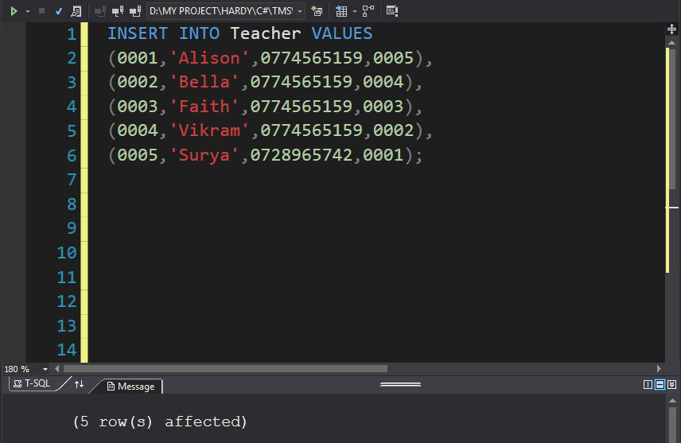

Figure : Teacher table insert data query

Now a table called Teacher is created, with 4 columns of data types of TeacherID, Name, Contact_Number and ClassID respectively, integer, varchar, integer and integer . The primary key is TeacherID so it is naturally unique and NULL. The foreign key is ClassID references class table. The insert query contains only the data types that are subject to the table's scheme, so the data is valid and the data entered.

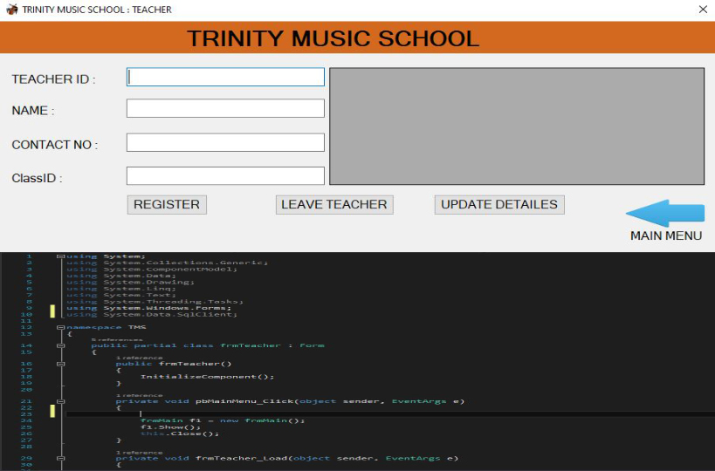

Figure : Teacher form design and code

### **Class**

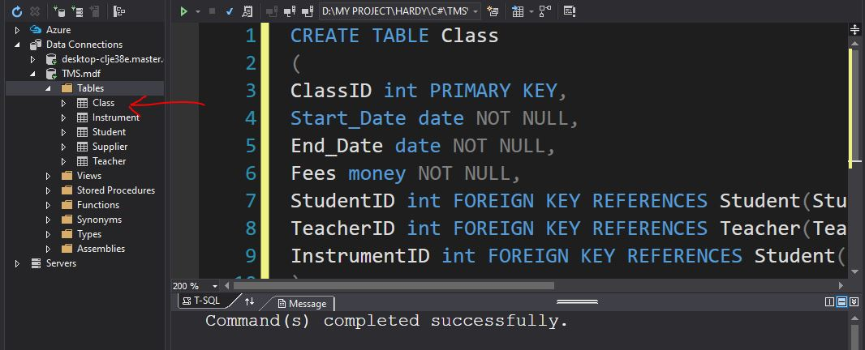

Figure : Class table create query

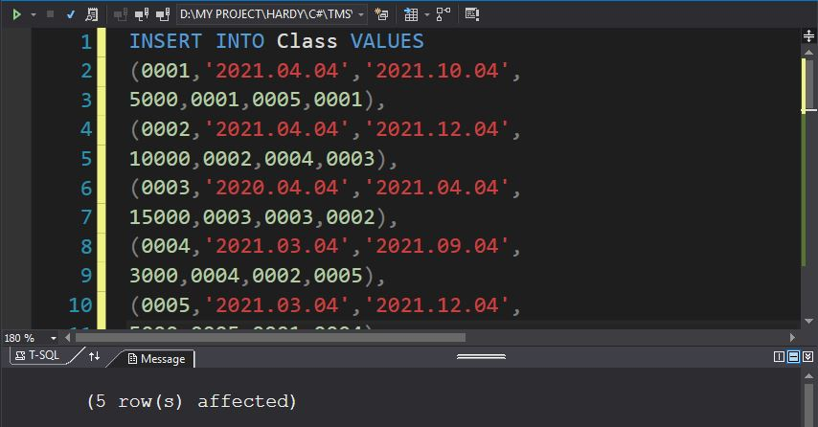

Figure : Class table insert data query

Now a table called Class is created, with 7 columns of data types of ClassID, Start_Date, End_Date, Fees, StudentID, TeacherID and InstrumentID respectively, integer, date, date, money, integer, integer and integer. The primary key is ClassID, so it is naturally unique and NULL. The foreign key is StudentID, TeacherID and InstrumentID references Student table, Teacher table and Instrument table.The insert query contains only the data types that are subject to the table's scheme, so the data is valid and the data entered.

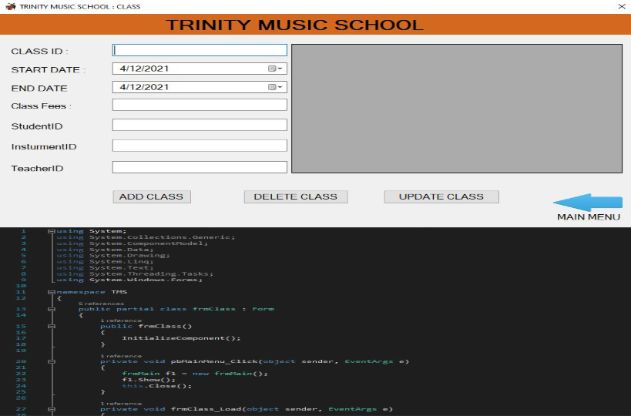

Figure : Class interface design and code

### **Supplier**

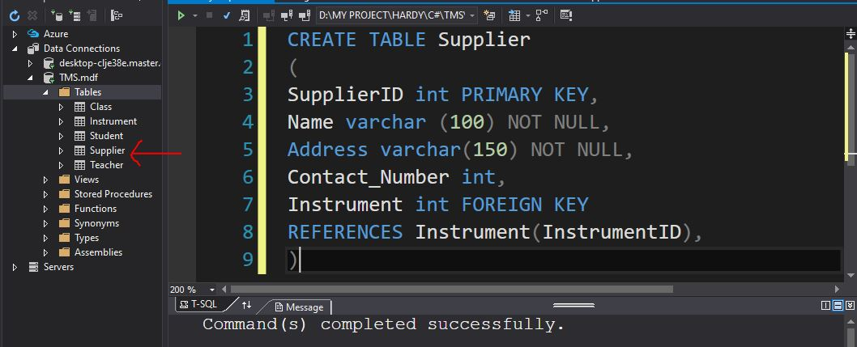

Figure : Supplier table create query

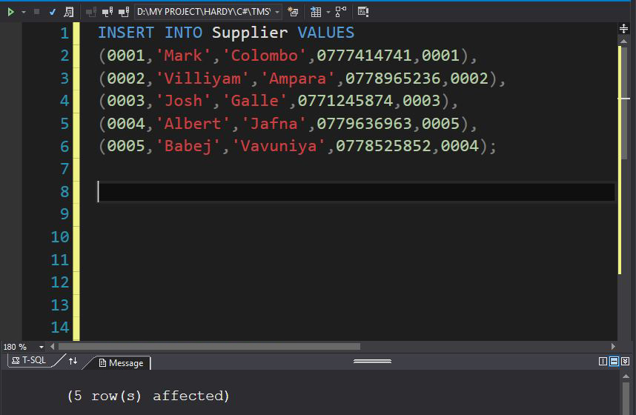

Figure : Supplier table insert data query

Now a table called Supplier is created, with 5 columns of data types of SupplierID, Name, Address, Contact_Number and InstrumentID respectively, integer, varchar, varchar, integer and integer. The primary key is SupplierID, so it is naturally unique and NULL. The foreign key is InstrumentID references Instrument table. The insert query contains only the data types that are subject to the table's scheme, so the data is valid and the data entered.

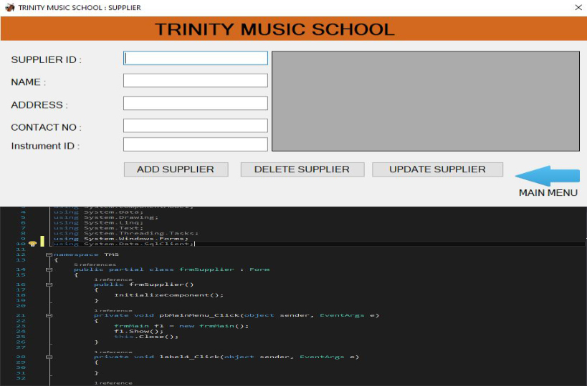

Figure : Supplier interface design and code

### **Instrument**

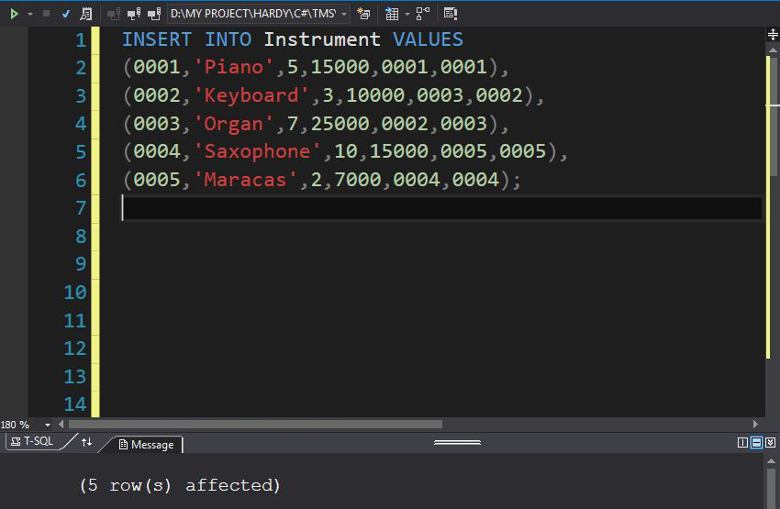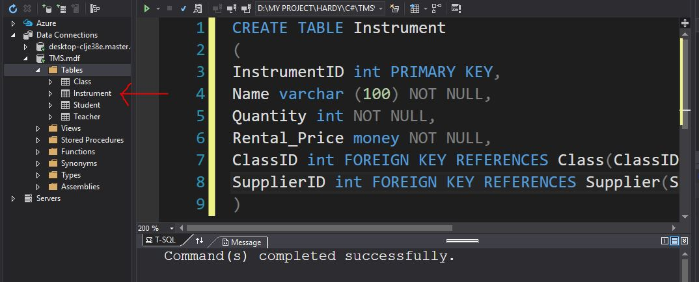

Figure : Instrument table insert data query

Figure : Instrument table create query

Now a table called Instrument is created, with 6 columns of data types of InstrumentID, Name, Quantity, Rental_Price, ClassID and SupplierID respectively, integer, varchar, integer, money, integer and integer. The primary key is IntrumentID, so it is naturally unique and NULL. The foreign key is ClassID and SupplierID references Class table and Supplier table. The insert query contains only the data types that are subject to the table's scheme, so the data is valid and the data entered.

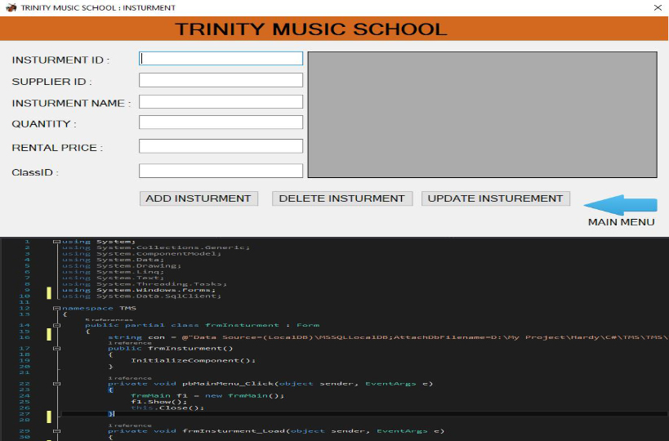

Figure : Instrument interface design and code

# **QUERY DEMONSTRATION**

Issues reported in the document will now be evaluated, then queries will be written and the output of the function of those queries will be displayed in the database.

## Task1: Student details with No of student registration for given month

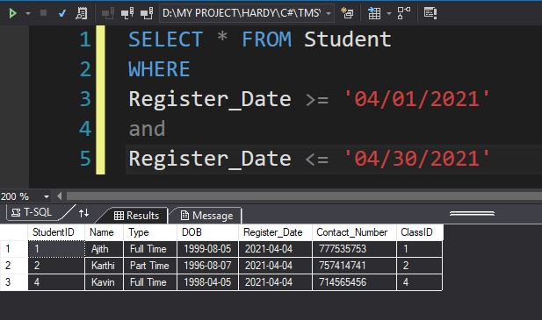

Figure : Task 1 Query

* I have taken Registered Month April 2021

## Task2: Total Income received for a given month form the student

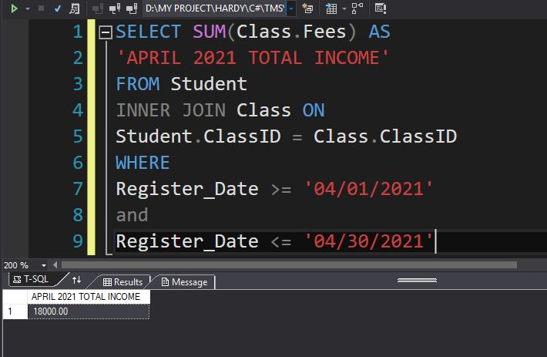

Figure : Task 2 Query

* I have taken Registered Month April 2021

## Task3: Student details with their playing instruments

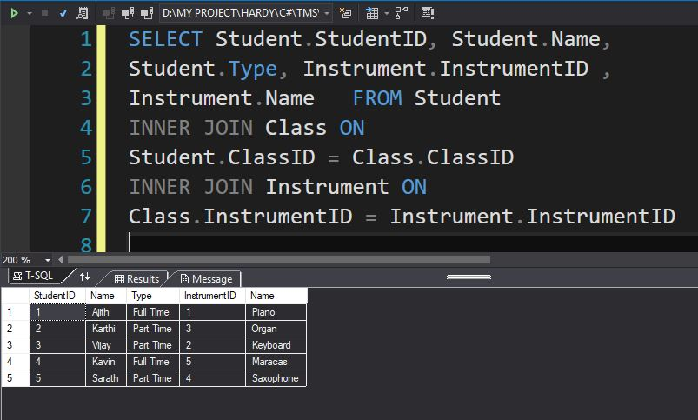

Figure : Task 3 Query

## Task4: Filter the student’s records based on the registration date

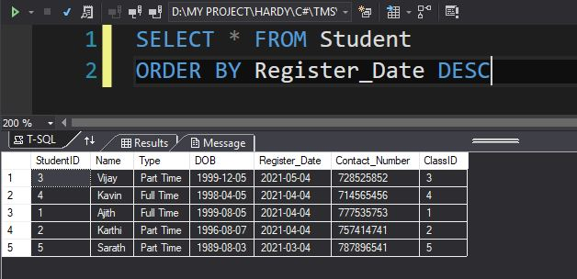

Figure : Task 4 Query

## Task5: Show only the Part time classes

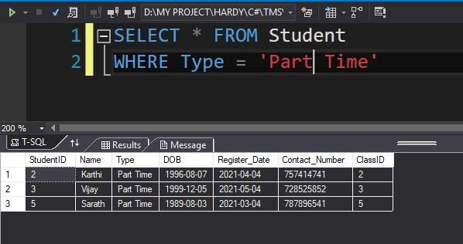

Figure : Task 5 Query

# References

Erkec, E., 2020. *SQLShack.* [Online]   
Available at: https://www.sqlshack.com/overview-of-microsoft-sql-server-management-studio-ssms/  
[Accessed 2021 04 05].

tutorialspoint, 2021. *SQL - Overview.* [Online]   
Available at: https://www.tutorialspoint.com/sql/sql-overview.htm  
[Accessed 2021 04 05].